**MIS - UNIT 2**

**Planning and Decision Making:**

**Planning**

Planning is a process of determining the goals and objectives and evolving strategies, policies, programmes and procedures for the achievement of these goals.

**Information Planning :** The Information Planning can be described as the perception of opportunities, problems and alternatives surrounding the achievement of the objectives.

**The Planning functions:**

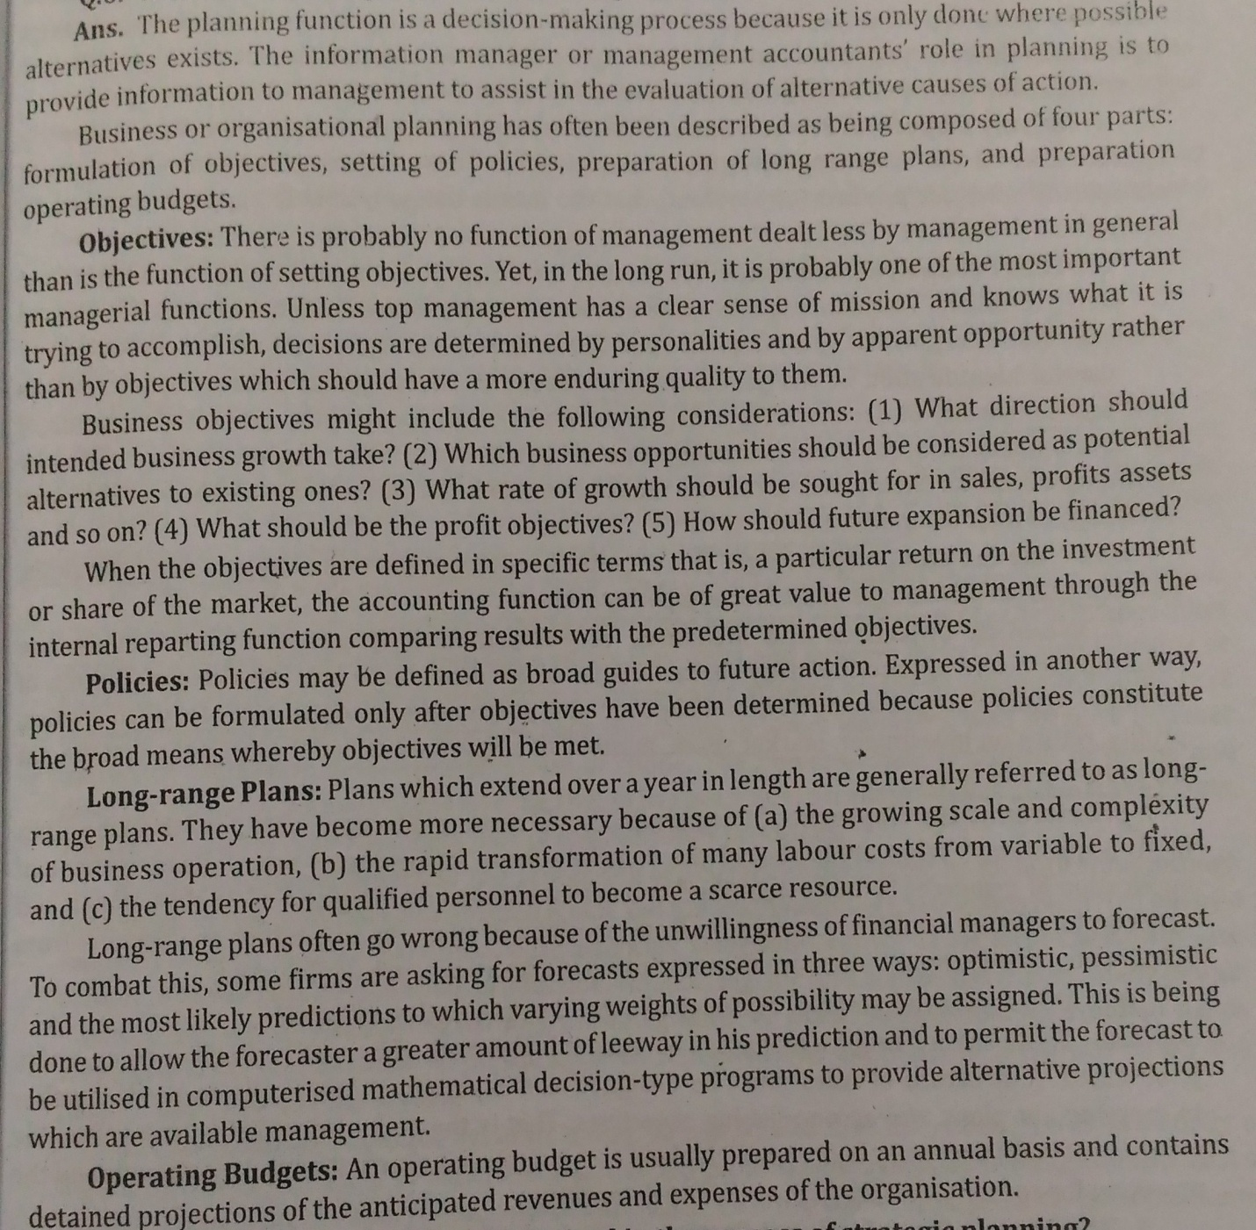

# Corporate Planning

Corporate planning is creating a strategy for meeting business goals and improving your business. A corporate plan is a roadmap that lays out your business’s plan of action. It is imperative to write down goals and plan for how they will be achieved. Without planning, business operations can be haphazard, and employees are rarely on the same page. When you focus on corporate planning, you set achievable goals and bring your business one step closer to success.

**Corporate Planning Definition**

Corporate planning is the act of creating a long-term plan to improve your business. A corporate plan examines a business’s internal capabilities and lays out strategies for how to use those capabilities to improve the company and meet goals. Think of a corporate plan as a roadmap laying out everything you need to do to achieve your future goals and reach new levels of success. The plan looks at each sector of a business and makes sure that all parts are aligned, working towards similar goals. Corporate planning is often looked at through a SWOT analysis (strengths, weaknesses, opportunities, threats). Further, it usually starts with broad goals and works its way towards a much more detailed analysis, laying out exactly how objectives will be reached. The following elements tend to be in a corporate plan:

* **Vision statement:** You company’s vision statement broadly defines what goals you are working to achieve. This statement is where you hone in on your business’s focus and what you want to accomplish over the next three-to-five years. Think big, but remember that you will have to create a strategic plan to back these goals up. So always make sure that your goals can be defined as SMART goals (strategic, measurable, achievable, realistic and time-based).
* **Mission statement**: A good mission statement lays out how you will achieve your vision statement in a few sentences. It should illustrate what you plan to offer or sell, the market you are in, and what makes your company unique. A mission statement is like an elevator pitch for your entire strategy. It effectively communicates who you are and what you want to do in a few lines.
* **Resources and scope**: Part of corporate planning is taking stock of everything you currently have going on in your organization. You'll look at your systems, products, employees, assets, programs, divisions, accounting, finance and anything else that is critical to meeting your vision. This part is almost like making a map of your current organization. It gives you a bird’s eye view of everything your company has going on, which helps you create a plan for moving towards the future.
* **Objectives**: Next, you need to lay out your business objectives and how you plan to measure success. This is a good time to hone in on that SMART planning to ensure that your objectives are strategic, measurable, achievable, realistic and time-based. A vague goal such as “improve brand reputation” is meaningless without a solid measure of success in place. A SMART goal would instead be “improve brand reputation by placing the product in five positive media stories by the end of Q1.”
* **Strategies**: Now, it’s time to illustrate the strategies you plan to use to meet the objectives of your company. These strategies could be anything from introducing new products to reducing labor costs by 25 percent, depending on the goal. Your strategies should directly address the objectives you have laid out in your corporate plan, and include a plan of action for how you will implement them. These are the nitty-gritty plan details.

**Corporate Planning Examples**

The needs of your corporate planning will vary depending on your business and industry. For example, for automotive giant GM, CEO Mary Barra’s corporate turnaround strategy included several objectives. The main ones included becoming a leader in product and technology, growing the Cadillac brand, continuing to grow the GM brand in China, continuing to improve GM’s finances and becoming more efficient from an operational standpoint. These objectives are, of course, tailored to GM’s specific needs as a company.

The following are a few examples of corporate planning objectives:

* **Financial objectives**: Presumably, you went into business to make money. Your corporate planning financial objectives are your money-oriented goals. These objectives can include growing shareholder value, increasing profits and generating more revenue, to name a few. However, not all financial objectives are about revenue and profits. There are also objectives on cutting costs, balancing budgets, maintaining proper budget ratios and more. Another financial objective example might be diversifying or creating new revenue streams. Your specific goals will depend on your company’s individual needs, but most corporate plans include at least a few financial objectives.
* **Customer objectives**: Your customer objectives center on what you plan to do for your customers. A customer-centered objective could be giving your consumers the best value for the price they pay. Or, you could aim to improve product reliability. Another customer objective is increasing your market share or offering the best possible customer service. These objectives will vary, but they all center around meeting customer demand.
* **Internal objectives**: It’s important to consider internal objectives when doing corporate planning. Internal objectives include three areas: innovation, operations and customer service. Innovation objectives might consist of improving a product or growing the percentage of sales of a particular product. Another innovation objective might be to invest x dollars in the innovation of products. Operations objectives focus on reducing waste, investing in quality, improving workplace safety and reducing errors in manufacturing, to name a few. Another potential operations objective is streamlining. Finally, customer service objectives center on improving customer service, retention and satisfaction.
* **Learning and growth objectives:** Every organization needs learning and growth objectives when corporate planning. Learning and growth objectives are those that involve employees, your company culture and your business’s organizational capacity. One possible example of a learning and growth objective is boosting company culture, increasing employee retention and improving productivity.

# Strategic planning

Strategic planning is an organization's process of defining its strategy, or direction, and making decisions on allocating its resources to pursue this strategy. It may also extend to control mechanisms for guiding the implementation of the strategy. It is executed by strategic planners or strategists, who involve many parties and research sources in their analysis of the organization and its relationship to the environment in which it competes.

Strategic planning is an organizational management activity that is used to set priorities, focus energy and resources, strengthen operations, ensure that employees and other stakeholders are working toward common goals, establish agreement around intended outcomes/results, and assess and adjust the organization's direction in response to a changing environment. It is a disciplined effort that produces fundamental decisions and actions that shape and guide what an organization is, who it serves, what it does, and why it does it, with a focus on the future. Effective strategic planning articulates not only where an organization is going and the actions needed to make progress, but also how it will know if it is successful.

The Process of Strategic Planning

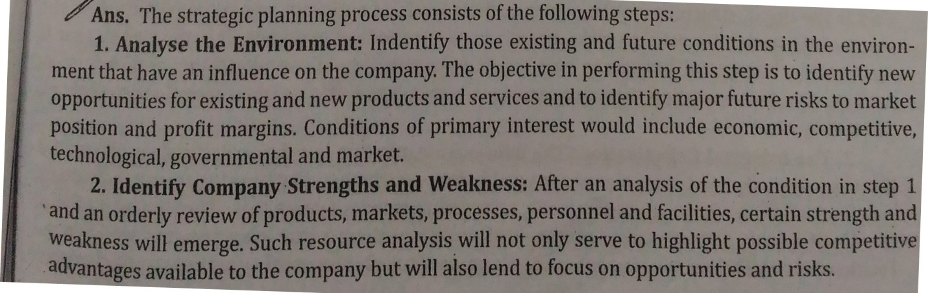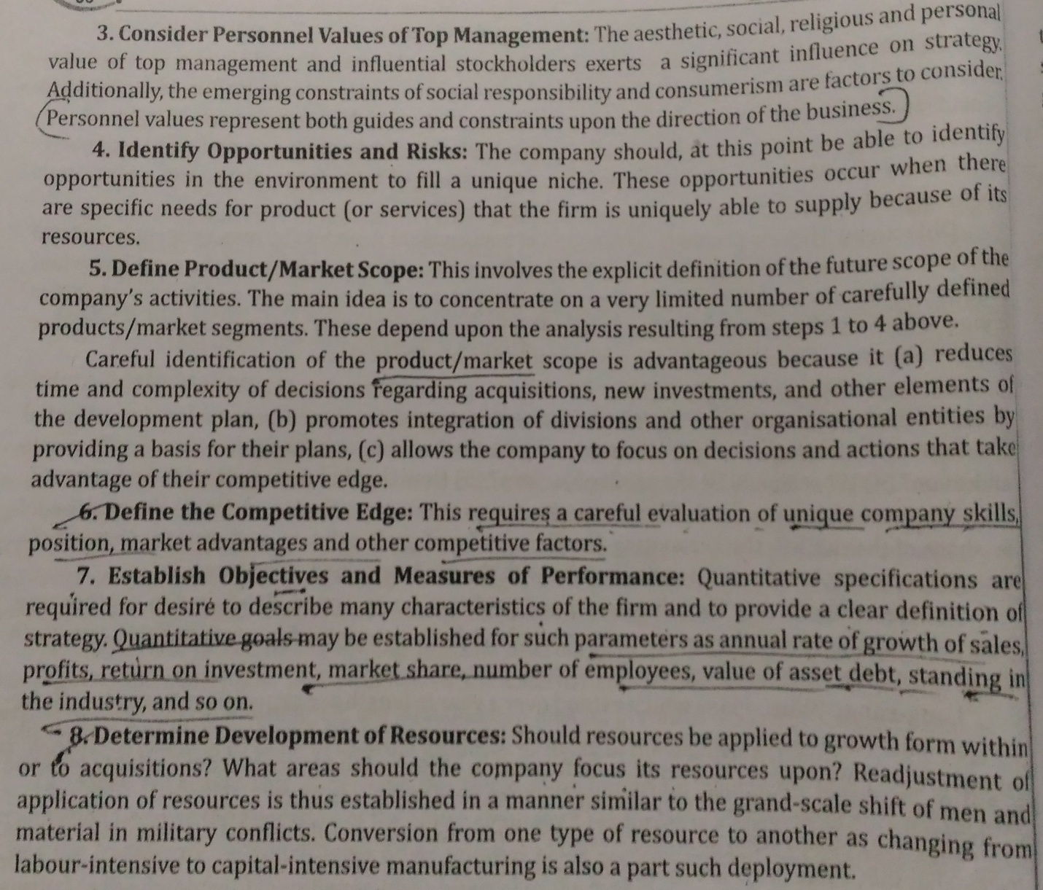

Types of Strategic Planning and tools of Planning

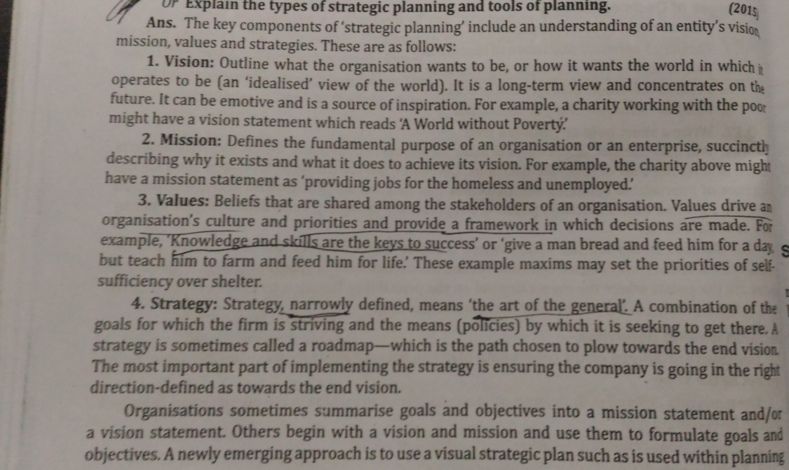

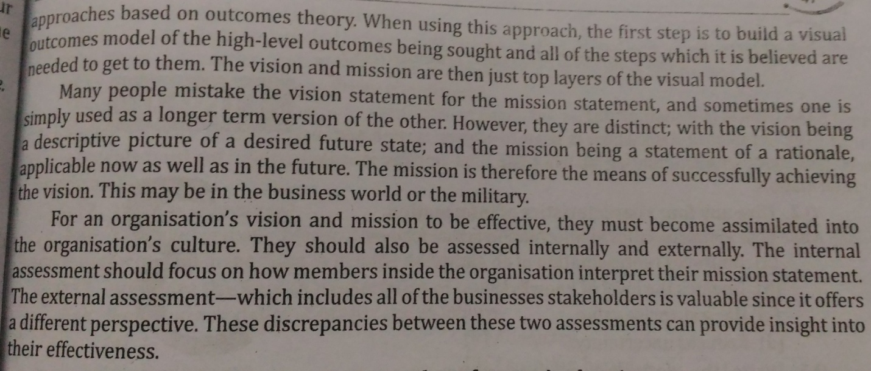

**MIS –Business Planning**

It is necessary to develop the goals and objectives for the MIS which will support the business goals. The MIS goals and objectives will consider management philosophy, policy constraints, business risks, internal and external environment of the organization and the business.

 The goals and the objectives of the MIS would be so stated that they can be measured.

 The typical statements of the goals are as under:

* Provide on-line information on the stocks, markets and the accounts balances.
* The query processing should not exceed more than three seconds.
* The focus of the system will be on the end user computing and access facilities.
* Information support will be the first in the strategic areas of management such as marketing or service or technology.

  Table: Business Plan versus MIS Plan

|  |  |
| --- | --- |
| **Business Plan** | **MIS Plan** |
| Business goals and objectives. | Management information system, objectives, consistent to the business goals and objectives. |
| Business plan and strategy | Information strategy for the business plan implementation playing a supportive role. |
| Strategy planning and decisions. | Architecture of the Management Information system to support decisions. |
| Management Plan for execution and control. | System development schedule, matching the plan execution. |
| Operation plan for the execution. | Hardware and software plan for the procurement and the implementation. |

 Such statements of the goals and objectives enable the designer to set the direction and design implementation strategies for the MIS.

 Strategy for the plan achievement: The designer has to take a number of strategic decisions for the achievement of the MIS goals and objectives. They are:

 a.                  Development strategy: An online, a batch, a real time.

 b.                  System Development Strategy: An approach to the system development – Operational versus Functional; Accounting versus Analysis; Database versus Conventional Approach; Distributed versus Decentralized processing; one Database versus Multiple database SSAD vs. OOT.

 c.                  Resource for System Development: In-house versus external, customized development versus the use of packages.

**Decision Making**

Decision making involves the selection of a course of action from among two or more possible alternatives in order to arrive at a solution for a given problem.

Characteristics of Decision Making

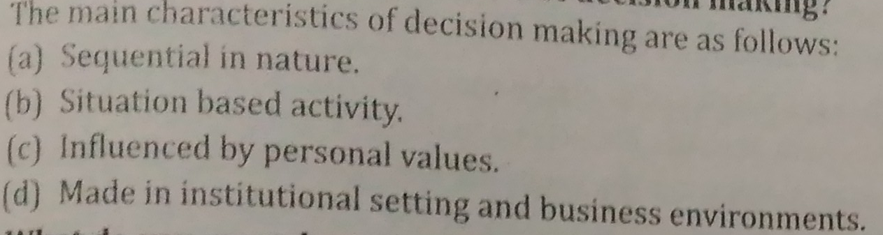

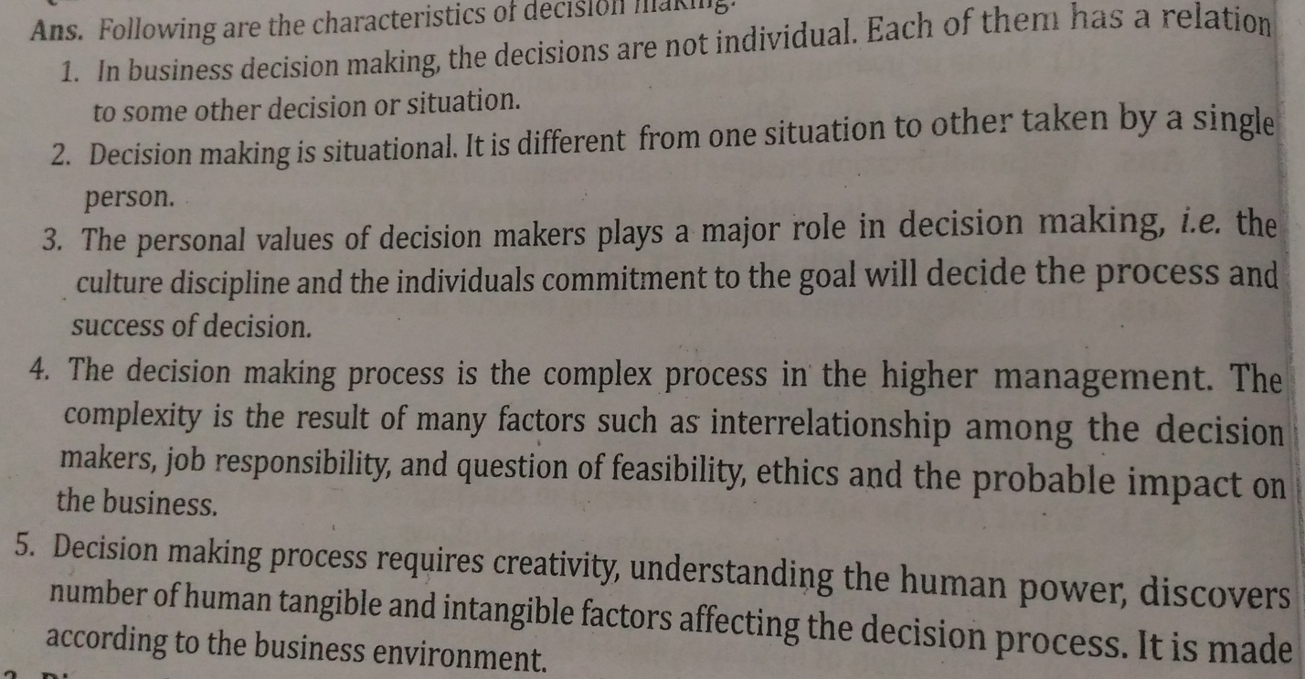

Advantages of Decision Making

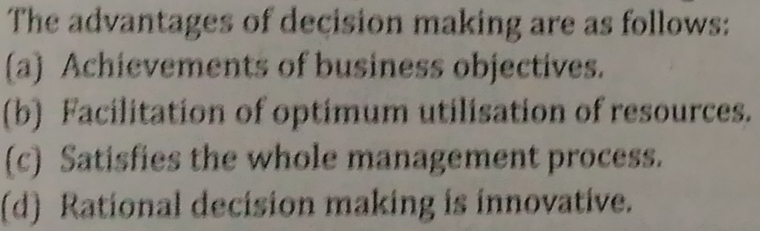

Open Decision Making

If the manager operates in an environment not known to him, then decision making is called as open decision making.

Closed Decision Making

If the manager operates in a known environment, then it is called as closed decision making.

Decision Making Process

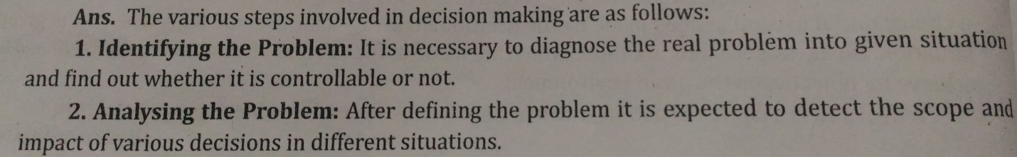

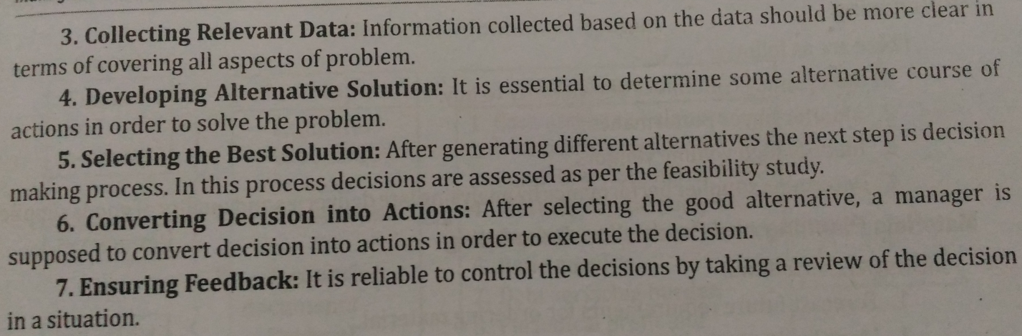

Decision Making Concept

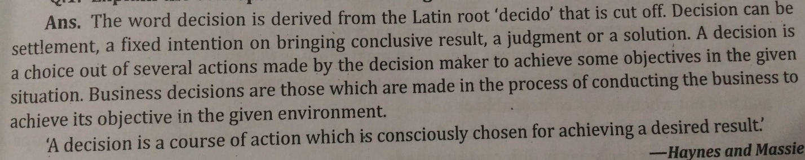

**Decision making** means to select a course of action from two or more alternatives. It is done to achieve a specific objective or to solve a specific problem.

According to **James Stoner**,

"Decision making is the process of identifying and selecting a course of action to solve a specific problem."

According to **Trewartha and Newport**,

"Decision making involves the selection of a course of action from among two or more possible alternatives in order to arrive at a solution for a given problem."

## Methods of Decision Making

There’s four common ways of making decisions:

1. **Command** – decisions are made with no involvement.
2. **Consult** – invite input from others.
3. **Vote** – discuss options and then call for a vote.
4. **Consensus** – talk until everyone agrees to one decision.

## 1. Command Style Decision Making

Command is when there’s no involvement:

“Let’s start with decisions that are made with no involvement whatsoever.  This happens in one of two ways.  Either outside forces place demands on us (demands that leave us no wiggle room), or we turn decisions over to others and then follow their lead.  We don’t care enough to be involved – let someone else do the work.”

## 2. ****Consult Style Decision Making****

Consult is when you ask for input:

“Consulting is a process whereby decision makers invite others to influence them before they make their choice.  You can consult with experts, a representative population, or even everyone who wants to offer an opinion.

Consulting can be an efficient way of gaining ideas and support without bogging down the decision making process.  At least not too much.  Wise leaders, parents, and even couples frequently make decisions in this way.  They gather ideas, evaluate options, make a choice, and then inform the broader population.”

## 3. ****Vote Style Decision Making****

Vote is when team members agree to support whatever decision is made:

“Voting is best suited to situations where efficiency is the highest value – and you’re selecting from a number of good options.  Members of the team realize they may not get their first choice, but frankly they don’t want to waste time talking the issue to death.

They may discuss options for a while and then call for a vote.  When facing several decent options, voting is a great time saver but should never be used when team members don’t agree to support whatever decision is made.  In these cases, consensus is required.”

## 4. Consensus Style Decision Making

Consensus is when there’s high stakes or you need everyone to fully support the final decision:

This method can be both a great blessing and a frustrating curse.  Consensus means that you talk until everyone honestly agrees to one decision.  This method can produce tremendous unity and high-quality decisions.  If misapplied, it can also be a horrible waste of time.  It should only be used with (1) high-stakes and complex issues or (2) issues where everyone absolutely must support the final choice.

## How To Choose Which Decision Method to Use

1. **Who cares?**  Determine who genuinely wants to be involved in the decision along with those who will be affected.  These are your candidates for involvement.  Don’t involve people who don’t care.
2. **Who knows?**  Identify who has the expertise you need to make the best decision.  Encourage these people to take part.  Try not to involve people who contribute to new information.
3. **Who must agree?**  Think of those whose cooperation you might need in the form of authority of influence in any decisions you might make.  It’s better to involve these people than to surprise them and then suffer their open resistance.
4. **How many people is it worth involving?**  Your goal should be to involve the fewest number of people while still considering the quality of the decision along with the support that people will give it.  Ask: “Do we have enough people to make a good choice?  Will others have to be involved to gain their commitment?”

# Decision Making – Tools and procedures

Decision making is a very important and complex process. In order to aid decision makers make the right choice, quantitative techniques are used that improve the overall quality of decision making.

Following are some of the commonly used techniques −

## Decision Trees

Decision Trees are tools that help choose between several courses of action or alternatives. They are −

* Represented as tree-shaped diagram used to determine a course of action or show a statistical probability.
* Each branch of the decision tree represents a possible decision or occurrence.
* The tree structure shows how one choice leads to the next, and the use of branches indicates that each option is mutually exclusive.
* A decision tree can be used by a manager to graphically represent which actions could be taken and how these actions relate to future events.

## Delphi Technique

Delphi Technique is a method used to estimate the likelihood and outcome of future events. It is unique because −

* It is a group process using written responses to a series of questionnaires instead of physically bringing individuals together to make a decision.
* Individuals are required to respond to a set of multiple questionnaires, with each subsequent questionnaire built from the information gathered in the previous one.
* The process ends when the group reaches a consensus.
* The responses can be kept anonymous if required.

## Payback Analysis

Payback analysis is a technique generally used in financial management.

* It refers to the period of time required to recoup the funds expended in an investment, or to reach the break-even point.
* It is generally used to evaluate capital-purchasing alternatives.
* Alternatives are ranked according to the time each takes to pay back its initial cost.
* The strategy is to choose the alternative that has the quickest payback of the initial cost.

## Simulations

Simulation is a technique that attempts to replace and amplify real experiences with guided techniques.

* It is a widely used technique in operations research.
* It models the behavior of individual elements within a given system.
* Methods generally used in simulation are random sampling to generate realistic variability.
* The overall behavior of the system emerges from the interactions between the elements.
* Widely used application areas of the simulation technique are - logistics and supply chain, service and operations management, business process improvement, health and social care information system, environment, etc.

Organizational Decision Making

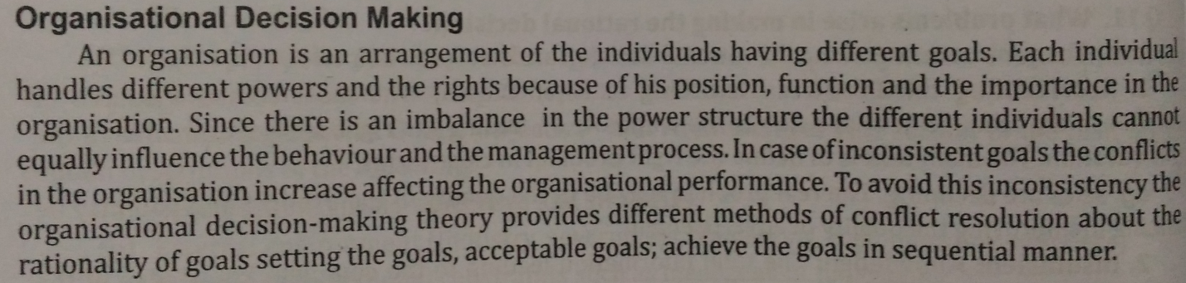

**MIS AND DECISION MAKING CONCEPTS**

DECISION-MAKING CONCEPT:

A decision is choice out of several alternatives (options) made by the decision maker to achieve some objective s in a given situation. Business decisions are those, which are made in the process of conducting business to achieve its objective in a given environment. Managerial decision-making is a control point for every managerial activity may be planning, organizing, staffing, directing, controlling and communicating. Decision-making is the art of reasoned and judicious choice out of many alternatives. Once decision is taken, it implies commitment of resources.

The business managers have to take variety of decision. Some are routine and others are long-term implementation decision. Thus managerial decisions are grouped as:

(**a) Strategic decision**

**(b) Tactical decision**

**(c) Operation decision**

1.       **Strategic Decision:** these are known as major decision influence whole or major part of the organization. Such decisions contribute directly to the achievement of common goals of the organization; have long range effect upon the organization.

Generally, strategic decision is unstructured and thus, a manager has to apply his business judgment, evaluation and intuition into the definition of the problem. These decisions are based on partial knowledge of the environmental factors which are uncertain and dynamic, therefore such decision are taken at the higher level of management.

2.       **Tactical Decision:** tactical decision relate to the implementation of strategic decisions, directed towards developing divisional plans, structuring workflows, establishing distribution channels, acquisition of resources such as men, materials and money. These decisions are taken at the middle level of management.

3.       **Operational Decision:** operational decisions relate to day-to-day operations of the enterprise having a short-term horizon and are always repeated. These decisions are based on facts regarding the events and do not require much of business judgments. Operational decisions are taken at lower level of management.

**MIS AND DECISION-MAKING**

It is necessary to understand the concept of decision-making as they are relevant to the design of the MIS. The Simon model provides a conceptual design of the MIS and decision-making wherein the designer has to design the system in such a way that the problem is identified in precise terms. That means the data gathered for data analysis should be such that it provides diagnostics and also provide a path to bring the problem to surface.

In the design phase of the model, the designer is to ensure that the system provides models for decision-making. These models should provide for the generation of decision alternatives, test them and pave way for the selection of one of them. In a choice phase, the designer must help to select the criteria to select one alternative amongst the many.

The concept of programmed decision-making is the finest tool available to the MIS designer, whereby he can transfer decision-making from a decision-maker to the MIS and still retain the responsibility and accountability with the decision maker or the manager. In case of non-programmed decisions, the MIS should provide the **decision support systems** provide a generalized model of decision-making.

The concept of decision-making system, such as the closed and the open system, such as the closed and the open systems, helps the designer in providing design feasibility. The closed systems are deterministic and rule based, therefore, the design needs to have limited flexibility, while in an open system, the design should be flexible to cope up with the changes required from time to time.

The methods of decision-making can be used directly in the MIS provided the method to be applied has been decided. A number of decision-making problem calls for optimization, and operational models are available which can be made a part of the system, the optimization models are static and dynamic, and both can be used in the MIS. Some of the problems call for a competitive analysis, such as payoff analysis. In these problems, the MIS can provide the analysis based on the gains, the regrets and the utility.

The concept of the organizational and behavioral aspects of decision-making provides an insight to the designer to handle the organizational culture and the constraints in the MIS. The concepts of the rationality of a business decision, the risk awareness of the managers and the tendency to avoid an uncertainty, makes the designer conscious about the human limitations and prompts him to provide a support in the MIS to handle these limitations. The reliance on organizational learning makes the designer aware of the MIS and makes him provide the channels in the MIS to make the learning process more efficient.

The relevance of the decision-making concepts is significant in the MIS design. The significance arises out of the complexity of decision-making, the human factors is the decision-making, the organizational and behavior aspects, and the uncertain environments. The MIS design addressing these significant factors turns out to be the best design.